1. Objectives
1. Understand the core concepts of Kubernetes, including Pod, Deployment, and Service.
2. Learn how to start a local Kubernetes cluster using Minikube.
3. Practice basic operations such as deploying, exposing, scaling, and updating applications.

2. Environment Setup
Operating System: Windows 11
Environment: Docker Desktop (Kubernetes enabled), Minikube, kubectl
Kubernetes Version: v1.31+
Minikube Driver: Docker

3. Experiment Steps

Step 1: Start Minikube Cluster
Run the following command in PowerShell or CMD:
minikube start --driver=docker
Verify that the cluster is running:
kubectl get nodes
If the node status is Ready, the cluster has started successfully.
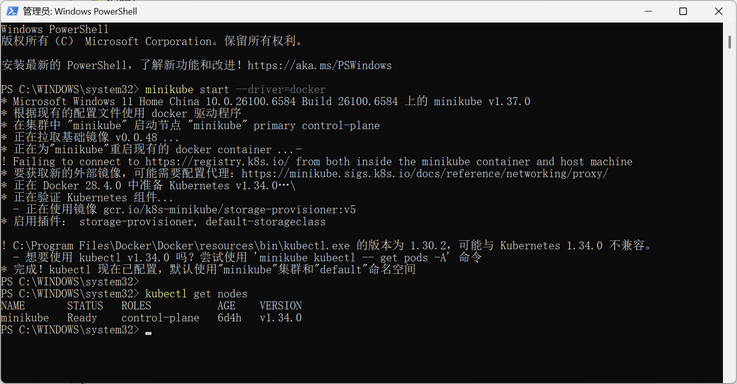 Minikube node status Ready.

Step 2: Deploy a Sample Application
Create a sample application:
kubectl create deployment hello-minikube --image=kicbase/echo-server:1.0
Check the Pod status:
kubectl get pods
Wait until STATUS shows Running.
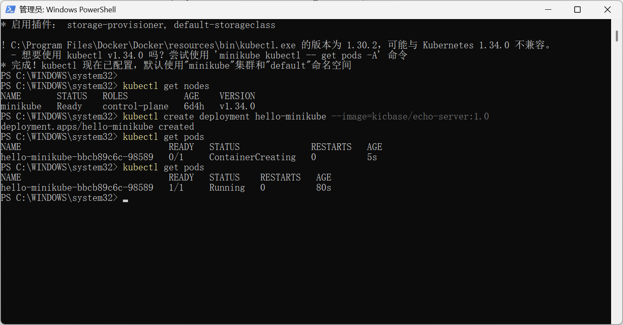 Pods in Running state.

Step 3: Expose the Service
Expose the application via a Service:
kubectl expose deployment hello-minikube --type=NodePort --port=8080
List services:
kubectl get services
Access the service:
minikube service hello-minikube
or view the URL directly:
minikube service hello-minikube --url
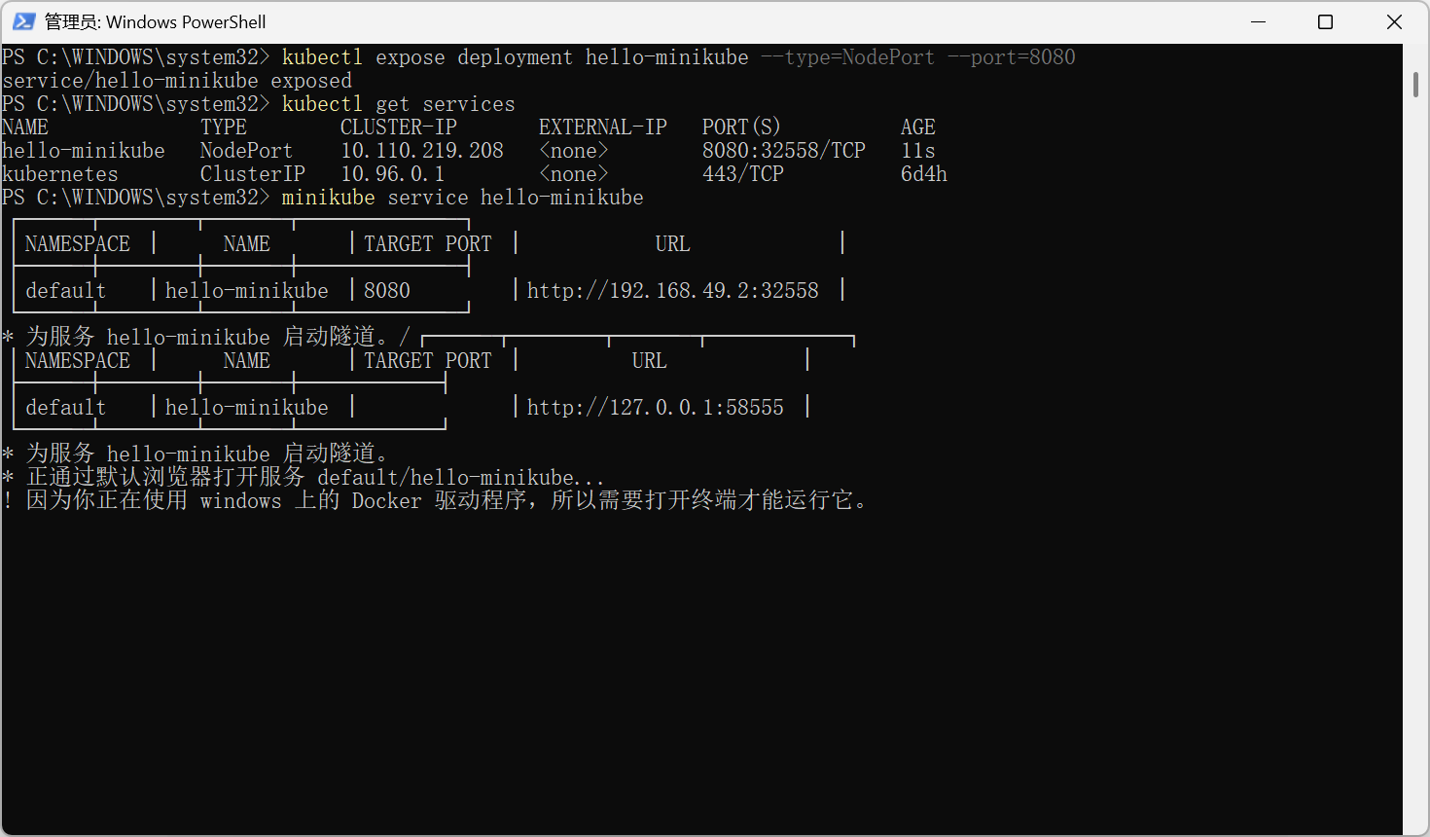
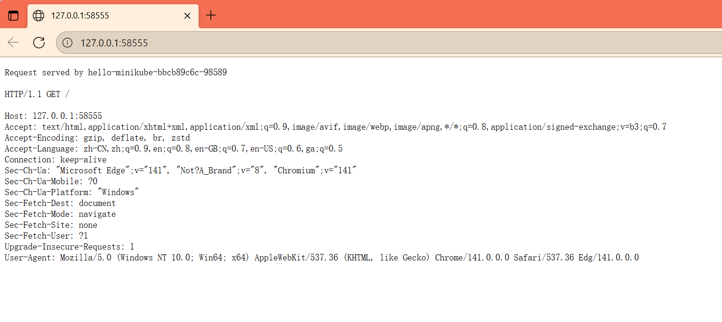Browser output of the service.

Step 4: Scale the Application
Scale to 3 replicas:
kubectl scale deployment hello-minikube --replicas=3
Check Pod status:
kubectl get pods
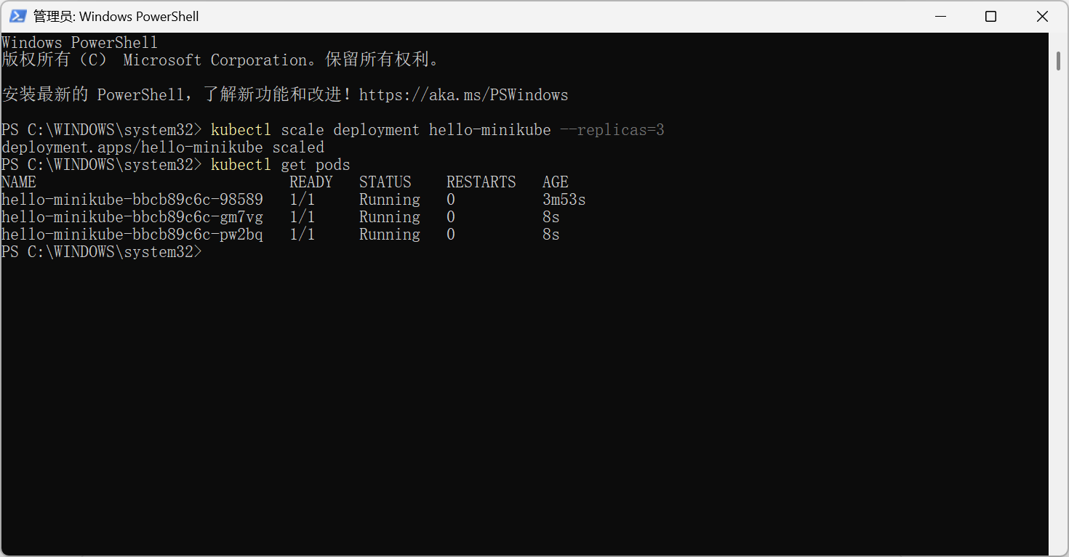 3 Pods running successfully.

Step 5: Update the Application
Update the image version:
kubectl set image deployment/hello-minikube hello-minikube=kicbase/echo-server:1.1
Monitor the rollout:
kubectl rollout status deployment/hello-minikube
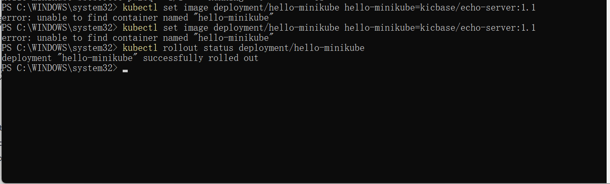 Application successfully updated.

Step 6: Clean Up Resources
After the experiment, clean up the resources:
kubectl delete service hello-minikube
kubectl delete deployment hello-minikube
minikube stop
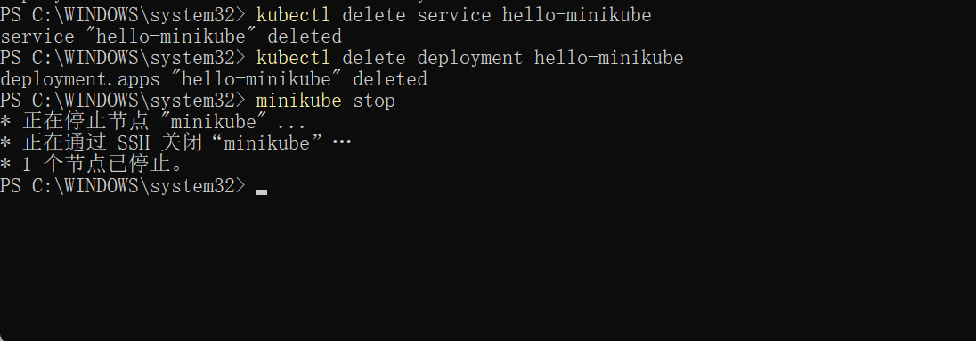

4. Results
The application was successfully deployed, exposed, scaled, and updated in the Minikube cluster. Screenshots show command outputs and browser access results.

5. Conclusion
Through this experiment, I learned how to operate a local Kubernetes cluster using Minikube, deploy applications, expose them via services, perform scaling and updates, and clean up resources. This provides a solid foundation for understanding Kubernetes orchestration and future cloud-native development.

